

Implementing Successful Email Campaigns :
Step-by-Step Guide and Workbook

2022 Edition

Kicking It Off

It seems simple enough to craft a clever email message, send it to your subscriber list, and then wait for the magic to happen. But there is so much more than the quick click you can gain from a single email. It just needs a plan.

We’ve created this actionable email workbook to guide you through what might seem a little tedious and a lot unnecessary. After all, it’s just an email, right? But why not use the email as the first step in building a meaningful, lasting relationship with your existing and to-be clients.

Think of each email as another conversation that grows the relationship rather than a one and done transaction. In fact, expecting a single email to close a quick sale is unrealistic. It takes time, patience, empathy, and consistency to get to “yes’.

Before you dive in, download the What’s Next Email Flowchart Template.

Let’s get started.

1
Before You Get Lost in the Details


It’s tempting to dive in and start creating your emails. But before you do, take a few minutes to answer these questions.

Your emails will become clearer, the outcomes more specific, and your audience more likely to engage.

- Who is this email for? Describe your audience in as much detail as possible.
Click or tap here to enter text.
- What problem does it solve for them?
Click or tap here to enter text.
- What is the offer?
Click or tap here to enter text.
- Why will the recipient open your email?
Click or tap here to enter text.
- What is the desired outcome?
Click or tap here to enter text.
- How will you measure success?
Click or tap here to enter text.
- What is the customer lifetime value for this offer?
Click or tap here to enter text.
- What is the desired clickthrough rate?
Click or tap here to enter text.
- How will you evaluate the results of this email?
Click or tap here to enter text.
- How will you use the results for the next email?
Click or tap here to enter text.
2
Your Mailing List
Your list of email subscribers is a valuable company asset. If you are just starting your email marketing journey, here are a few tips that will help you create, manage, and responsibility deliver value to your email list.

- It’s surprising that email senders are still using their Outlook email client to send mass emails. This is absolutely a do not do this ever tactic. You put your entire email account at risk of being identified as a spammer. This can result in your being blacklisted. Always use a reputable email marketing platform such as Mailchimp.

- Always get permission before adding someone to your email subscriber list. Not only is it the professional thing to do, but it is illegal to send emails without permission. We have seen cases where an email platform like Mailchimp has permanently banned an account because of illegal email tactics.

- A reputable email marketing platform will include the legally-required subscription options. If someone unsubscribes, don’t try to add them again. The platform will not allow it, and you are abusing a subscriber.

- Segmenting subscribers allows you to send more relevant, targeted emails. It’s a practice that benefits both you and your subscribers.

- How did you acquire the email addresses?
Click or tap here to enter text.
- Do you have permission to email each of these people?
Click or tap here to enter text.
- When was the last time this list was curated?
Click or tap here to enter text.
- Is the list organized by categories? The message should be personalized and very specific for the offer.
Click or tap here to enter text.
- What data do you have about each person on the list? The more personalized the email the greater the opportunity for engagement.
Click or tap here to enter text.
- Is each person on the list a candidate for your offer? One of the quickest ways to become known as a spammer and alienate a customer for any future engagement is to send them a completely irrelevant offer. Remember the tip about segmentation? This is where it becomes valuable.
Click or tap here to enter text.

3
Your Offer

- What is the offer?
Click or tap here to enter text.
- What do you want the recipient to do after they accept the offer? You will create workflows in the email flowchart template you downloaded.
Click or tap here to enter text.
- Does the offer include downloadable content?
Click or tap here to enter text.
- If so, who will create it?
Click or tap here to enter text.
- What is the title?
Click or tap here to enter text.
- What is the format?
Click or tap here to enter text.
- What is the URL?
Click or tap here to enter text.
- Where does this content live?
Click or tap here to enter text.
- If the offer is a video, blog post, ebook, or other online content, is it current?
Evergreen content is an excellent way to build your content library, but it should be updated from time to time. References that are no longer relevant will quickly turn off your audience and cause you to appear out of touch.
If the material includes the published date, make sure it’s a current date. How often have you clicked a link only to find a 2 or 3 year old video or post?
Click or tap here to enter text.
- What is the next touch after the recipient clicks the offer? You will map this out in detail in the Email Workflows section below.
Click or tap here to enter text.

4
The Landing Page

When your recipient clicks on your email’s offer link, you will take them to a landing page on your website. Unlike other website pages, the landing page should not include the menu and other navigation links.
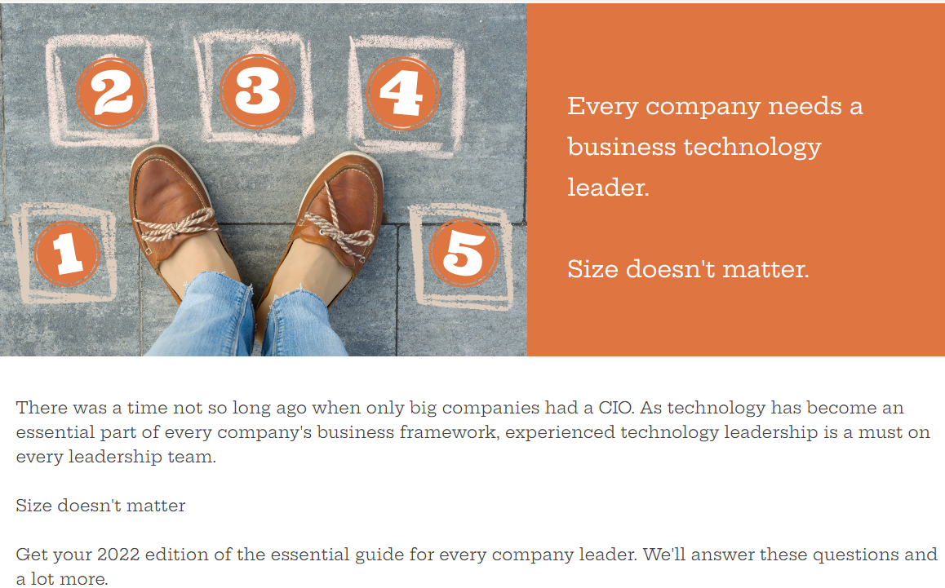
The purpose of this page is to simply complete the offer. This is not the time to continue selling or allow the visitor to navigate away from your offer.
We have all been victims of landing pages that try to collect too much information from us. It’s annoying, feels intrusive, and often leads to an abandoned offer. There’s time for more data gathering as you continue to build a relationship with your visitor. Keeping the required information to a minimum will encourage the visitor to complete the offer. Email and name are enough.
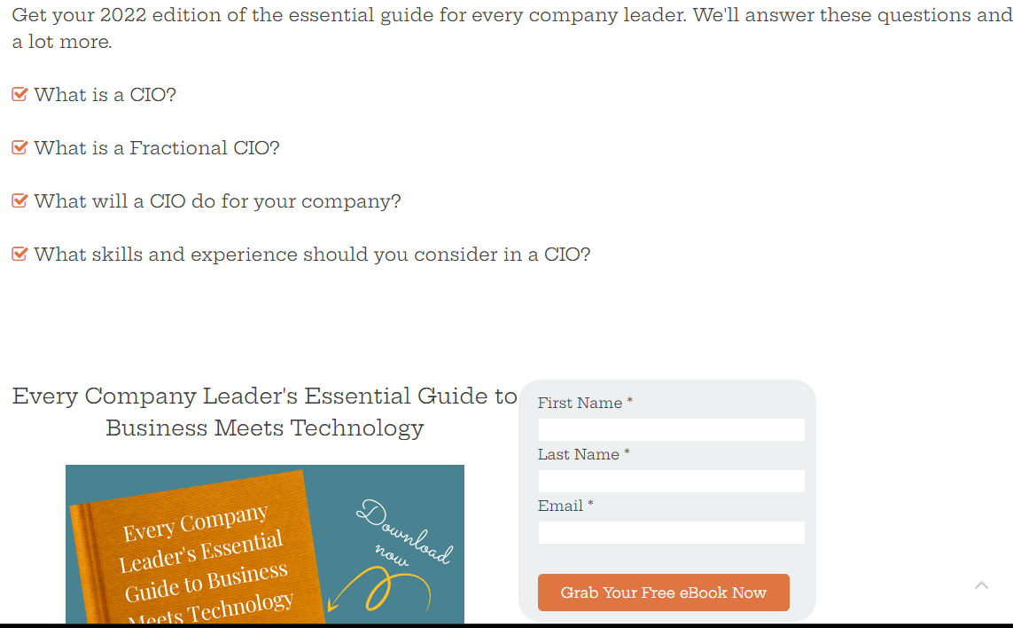

This landing page is also used to drive website visitors to your offer. Consider how this content fits into the overall flow of your website. Include appropriate links to this page from relevant site content. Not only will visitors discover your offer, but search engines will follow the links for indexing. You should give as much thought to the URL for this landing page as you do for all your website pages for the best SEO results.
You will continue to develop this relationship and gather more information with future offers, useful content, and authentic touches.

- What is the landing page URL?
Click or tap here to enter text.
- What is the single call to action?
Click or tap here to enter text.
- Is the landing page uncluttered with no distracting links, menus, or content? Click or tap here to enter text.
- What information about the visitor are you collecting?
Click or tap here to enter text.
- Where will this information be stored?
Click or tap here to enter text.
- Do you have at least one relevant link on your website to this landing page?
Click or tap here to enter text.
- Have you created a separate thank you page the visitor will see after he completes the offer click? What do you want the user to do next?
Click or tap here to enter text.

5
Build Your Image Library


Including high-quality images in your emails increases reader engagement. Make time to build or add to your image library as you complete this workbook.
Having images in advance not only will save you time when you’re ready to create your emails, but they can also inspire the message.
Images must be licensed for commercial use to avoid copyright infringement. We recommend both Unsplash and Pixabay. The images are high quality, free, and commercially licensed.
If you want to expand your creativity, Canva is an amazing tool. You can create impressive looking designs using the large library of templates, tools, images, and design help. Canva offers both free and premium versions.

6
Email Roadmap

Your subject line is the first thing your audience sees. It will entice the recipient to open the email or to quickly ignore it. This isn’t the place to be cute or clever. Tell your audience clearly and concisely why this email is one they want to read. Remember, the purpose of the email is to build a relationship between you and the recipient. It is not a quick sale tactic.

Your offer is the solution to your reader’s problem. The message should communicate genuine understanding and your commitment to deliver what your audience needs.
Each email should have one clear call to action that leads the reader toward a solution that matters to her.
When the first email lands in your audiences’ inboxes and the opens / clicks begin, it’s easy to lose sight of what happens next. The first email is just the beginning of an ongoing conversation with your audience. Mapping out the entire flow of multiple emails in advance will help avoid missed opportunities and eliminate a lot of now-what stress.
Grab a whiteboard, paper, a pad of sticky notes ---whatever works best for you. The purpose is to map the if-then-next decisions based on each user interaction. The flow goes like this:
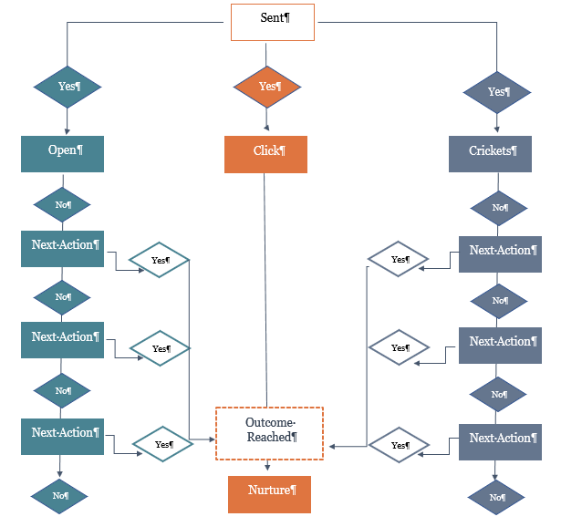
Each email action needs a different follow up. The message should be consistent with the original offer but written to learn more about the recipient’s interest. The more specific information you can gather about the recipient’s interest either now or in the future, the more likely you will continue to foster a meaningful relationship.
You will need to decide when to stop promoting an offer, consider another one, or simply stop contacting an unengaged recipient. There is a fine line between building engagement and becoming annoying so consider this carefully.
Download your fill-in-the-workflow-boxes roadmap template.

First Email
Subject
Click or tap here to enter text.
Body
Click or tap here to enter text.
Clear call to action
Click or tap here to enter text.

Second Email
First Email No Open
Subject
Click or tap here to enter text.
Body
Click or tap here to enter text.
Clear call to action
Click or tap here to enter text.

First Email Open but No Click
Subject
Click or tap here to enter text.
Body
Click or tap here to enter text.
Clear call to action
Click or tap here to enter text.

First Email Click
Subject
Click or tap here to enter text.
Body
Click or tap here to enter text.
Clear call to action
Click or tap here to enter text.

Third Email
Second Email No Open
Subject
Click or tap here to enter text.
Body
Click or tap here to enter text.
Clear call to action
Click or tap here to enter text.

Second Email Open but No Click
Subject
Click or tap here to enter text.
Body
Click or tap here to enter text.
Clear call to action
Click or tap here to enter text.

Second Email Click
Subject
Click or tap here to enter text.
Body
Click or tap here to enter text.
Clear call to action
Click or tap here to enter text.

Continue this flow for each of the three action types until you decide it’s time to stop with any of them.
What you can learn from the recipient’s action:
- Open = maybe interested based on your subject line or they already know and trust you
- No open = is your subject line compelling or are they simply not interested? You will need to discover the answer to this one.
- Click = they move down the offer funnel. More nurturing with relevant content that supports the offer and encourages continued engagement.
7
Managing the Email
- What tool will you use for this campaign?
Click or tap here to enter text.
- Does it provide the metrics you need to measure the desired outcome?
Click or tap here to enter text.
- Have you imported your curated email list into this tool?
Click or tap here to enter text.

8
Data Gathering and Analysis
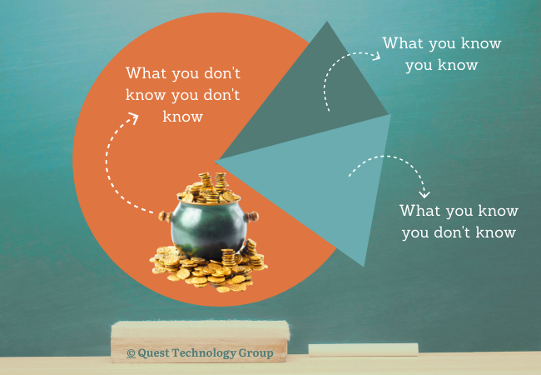
- What can you learn about each recipient to continue the conversation with them?
Click or tap here to enter text.
- Who and how will you gather this information?
Click or tap here to enter text.
- Where will the data be stored?
Click or tap here to enter text.
- Who will use this data?
Click or tap here to enter text.
- How will the data be accessed?
Click or tap here to enter text.
- Who will develop more content to continue engagement?
Click or tap here to enter text.
- How will you discover new opportunities for ongoing engagement?
Click or tap here to enter text.
- How will you manage the follow up schedule based on user activity, expected result?
Click or tap here to enter text.

9
Additional Content to Continue Engagement
- What other relevant content can you offer?
Click or tap here to enter text.
- What blog posts, articles have you published that can be used in future emails?
Click or tap here to enter text.


Let’s start the conversation.

Are you a DIYer? Want to hand the whole thing off to someone else? Not sure?
No problem. We can help you find the right approach for you.

Explore: www.quest-technology-group.com
Call: 407.843.6603
Email: learning@quest-technology-group.com

